|  |  |  |
| --- | --- | --- |
|  |  |  |

GOVERNMENT OF INDIA



**MINISTRY OF SKILL DEVELOPMENT & ENTREPRENEURSHIP**

DIRECTORATE GENERAL OF TRAINING

**NATIONAL SKILL TRAINING INSTITUTE**

NSTI (W), Salt Lake, Kolkata-700091

**CERTIFICATE**

This is to certify that following trainees have completed their project titled

**“NSTI Smart Cloud Campus”**

**For IBM Program – IT, Networking and Cloud (Technical Diploma)**

|  |  |
| --- | --- |
| ADIT19AU01323 | Sakshi Kumari |

|  |  |  |  |
| --- | --- | --- | --- |
| Mr. Lingaiah Boddu | Mr. K. L. Kuli | Mr. G. C. Ramamurthy | Mr. Sarbojit Neogi |
| IBM Faculty | ADIT Director | Principal | Section-In-Charge |

**ACKNOWLEDGEMENT**

We would like to express my sincere gratitude to several individuals and organizations for supporting me throughout my diploma study. First, I wish to express my sincere gratitude to my trainer, Mr. Lingaiah Boddu, for his enthusiasm, patience, insightful comments, helpful information, practical advice and unceasing ideas that have helped me tremendously at all times in my study and writing of the project report. His immense knowledge, profound experience and professional expertise in computer science has enabled me to complete the project successfully.

I also wish to express my sincere thanks to the National Skill Training Institute, Salt Lake for accepting me into the diploma program. In addition, I am deeply indebted to the Ministry of Skill Development & Entrepreneurship and IBM for granting me the diploma course. The technical and financial support has enabled me to complete my diploma course studies successfully. Also, I am grateful the Mr. Sarbojit Neogi faculty of NSTI Salt Lake for supporting me for course completion in the specific subject.

I am also grateful to the following NSTI Regional Director Sir Mr. K. L. Kuli and Principal Sir Mr. G. C. Ramamurthy for their consistent support and assistance.

**PROJECT ON Build an Application Using NodeJS Express and MongoDB (My Own Websites)**

*…..Submitted by*

***Sakshi Kumari***

**INDEX**

|  |  |  |
| --- | --- | --- |
| **Sr. No.** | **Table of Contents** | **Page No.** |
| 1 | Chapter 1: Introduction |  |
| 2 | Chapter 2: Services and Tools Required |  |
| 3 | Chapter 3: Project Architecture |  |
| 4 | Chapter 4: Architecture Blocks Detail Working |  |
| 5 | Project Budget |  |
| 6 | Conclusion |  |
| 7 | References |  |
| 8 | Code |  |

**CHAPTER 1**

**INTRODUCTION**

* 1. **Abstract**
  2. **Introduction**
  3. **Purpose**
  4. **Modules**
  5. **Scope**

**Abstract:**

This application is developed using NodeJS and the Express framework, when we want to interact with a MongoDB database from your code. Fortunately, this task is easy to accomplish using the Mongoose package for JavaScript. In this project I’ll show you how to create an application using NodeJS, Express and MongoDB.

**Introduction:**

This was done to get us ready for whatever facet we chose. A major part of this project is to show what we have learned and put it into practice.

**Purpose:**

The purpose of this document is to describe the functionality and specifications of the design of a web application and to learn how to build a simple web-based application using Node Js and Mongo DB.

Modules:

* Home
* About
* Service
* Video
* Classes
* Instructor
* Blog
* Contact us
* Mail
* Phone
* Login/Signup

**Scopes**

FEASIBILITY STUDY

After identifying the scope of the project, the feasibility study is needed to be carried out. It is basically keeping the following points in mind.

**Building the software for meeting the scope:**

The software has met the scope. As this is no data involved in the system, processing on the file, and the behavior of the project is already identified and bundled in quantitative manner. The processing of the software is very simple as it has been designed in php and it has been well divided into several functions according to the need.

**Technically feasible:**

The software is very much technically feasible. The software is very much concerned with specifying equipment and the software will successfully satisfy almost all the admin’s requirements.

The technical need for the system may vary considerably but might include:

a. The facility to produce output in a given time.

b. Response time under certain conditions.

c. Ability to process data at a particular speed. These for, the basic input/output of data is identified. So, the project can easily be build up and it will also be technically feasible.

**State of Art:**

The project is very much within the state of art since the project is a WINDOWS based; it uses very modern and common technique. Beside it is very much modern and user friendly. It also works as middleware i.e. only in between the user and the file. So, it is completely a state of art project.

**Financially Feasible:**

The project is very much financially feasible. The implementation and development cost of the software under the reach of any college.

Moreover, it requires some training for the use. So, training cost can be neglected and the resources of the software are very much available. It also reduces the labor and extra cost to be paid for labor. So indeed, it is financially feasible.

**Resources:**

As motioned earlier that the resources are easily available and the cost of training is almost negligible. Sometimes situations may arise when it may not be so much easy. For a person completely unaware of using a computer system could result in a training cost or for a very small organization the purchase of a computer, installment of the system and othis charges may lead to a difficult matter.

**CHAPTER 2:**

**SERVICES AND TOOLS REQUIRED**

**2.1 Services Used**

**2.2 Tools and Software used**

**Services Used:**

Npm packages

**Available Technologies:**

Languages: HTML, CSS, JavaScript.

Runtime: - Node Js.

Non-RDBMS: MongoDB

Library/Framework: Express, Mongoose, Bootstrap

**Tools Used:**

Editor Used: sublime

Operating System: Windows 10

Browser: - Chrome

Documentation: - MS Word

**Hardware Used:**

Processor: Intel core i3

RAM: 4GB

Hard Disk: 1TB

**CHAPTER 3**

**PROJECT ARCHITECTURE**

**3.1 Architecture**

**USER FRONTEND BACKEND**

|  |  |  |  |  |
| --- | --- | --- | --- | --- |
| **InternetUser** | Web design  HTML5 | |  | Node.js JavaScript npm Computer Icons Web application, text, logo png |  PNGEgg**NODEJS 14.0**  **Database** |
|  |  |  |  | |

**Chapter 4:**

**Architecture Blocks Detail Working**

|  |  |
| --- | --- |
|  |  |

DFD (DATA FLOW Diagram):

**Database (MongoDB)**

**Database Name: - customeredb**

**Collection Name: - customer**

**Structure:**

1. _id: By default, In MongoDB

2. Email: Enter the email_id of the user.

3. Name: Enter the name of the user.

4. Password: Enter Password

5. Date: select date

6. Time: select time

**Project Budget**

His we don’t need any cost for making this project.

**Conclusion:**

**While building an application using NodeJS, Express and MongoDB, it’s important to make sure everything is installed and configured correctly. In this project, hise covered those key steps in the process.**

**References**

**Websites:**

* [**https://www.w3schools.com/**](https://www.w3schools.com/)
* [**www.github.com**](http://www.github.com)
* [**www.tutorialspoint.com**](http://www.tutorialspoint.com)
* [**www.youtube.com**](http://www.youtube.com)
* [**www.nodejs.org**](http://www.nodejs.org)
* [**https://www.javatpoint.com/**](https://www.javatpoint.com/)

**Code**

**index.html**

**<!DOCTYPE html>**

**<html>**

**<head>**

**<link rel="stylesheet" href="/Public/css/only.css">**

**<title>Yoga</title>**

**<meta name="viewport" content="width=device-width, initial-scale=1">**

**<link rel="stylesheet" href="https://cdnjs.cloudflare.com/ajax/libs/font-awesome/4.7.0/css/font-awesome.min.css">**

**</head>**

**<body>**

**<div class="header">**

**<div class="one">**

**<marquee><a href="Signup.html"> &nbsp Welocome to Yoga fitness club &nbsp</a>**

**</marquee>**

**</div>**

**<div class="three">**

**<img src="/Public/image/logo.jpg"> </img>**

**<p align="left">**

**<ul><li>**

**<input type="text" placeholder="Search..">**

**</li>**

**</ul></p>**

**</div>**

**<div class="two">**

**<aside>**

**<table class="head" cellpadding="15px">**

**<tr>**

**<td><i href="login.html">Log In</i></td>**

**<td><i href="Signup.html">Sign Up</i></td>**

**</tr>**

**</table>**

**</aside>**

**<div class="menu">**

**<ul>**

**<li><a href="#"> Home</a>**

**<div class="sub1">**

**<ul>**

**<li><a href="#">Defination</a></li>**

**<li><a href="#">Types</a></li>**

**</ul>**

**</div>**

**</li>**

**<li><a href="#About">About</a>**

**<div class="sub1">**

**<ul><li><a href="#About">Servies</a></li>**

**<li><a href="#About">Video</a></li>**

**</ul>**

**</div> </li>**

**<li><a href="#Classes"> Classes</a></li>**

**<div class="sub1">**

**<ul><li><a href="#">Instructor</a></li></ul>**

**</div>**

**<li><a href="Blog">Blog</a></li>**

**<li><a href="#Contact">Contact Us</a>**

**<div class="sub1">**

**<ul>**

**<li ><a href="#">Email:-abc@gmail.com</a></li>**

**<li><a href="#">Call:-180045161</a></li></ul></div></li></ul></div>**

**</div></div>**

**<div class="a">**

**<div class="aa">**

**<p class="k">**

**Yoga– Yoga is essentially a spiritual discipline based on an extremely subtle science, which focuses on bringing harmony between mind and body. It is an art and scince of healthy living.**

**</p>**

**<img src="/Public/image/download.jpg"width=60% height="450px">**

**</img>**

**<p class="k">**

**There are four primary types of yoga..<br>**

**1)<b>Karma</b><br>Karma [KAR-muh] yoga isthe path of service through selfless action for the good of others<br>**

**2)<b>Bhakti</b><br>Bhakti [b-HUHK-tee] yoga cultivates the expression and love of the Divine through devotional rituals.<br>**

**3)<b>Jnana</b><br>nana [YAAH-nuh] yoga isthe path of intellect and wisdom, and its components include study of sacred texts, intellectual debates, philosophical discussion, and introspection.<br>**

**4)<b>Raja</b><br>Raja [RAAH-juh] yoga, also known as the "royal path," refers to the journey toward personal enlightenment.<br>**

**</p>**

**</div>**

**<div class="ac">**

**<H1 id="Overviews">OVERVIEWS</H1>**

**<p class="y">**

**Yoga, in the traditional sense, is a spiritual way of life that extends well beyond the complicated poses and breath work. The traditional practice of yoga is actually a rigorous spiritual discipline composed of a vast array of physical and mental exercises, in addition to philosophical, moral, and even nutritional practices, all aimed at self-transformation by union of the mind, body, and spirit. As such, yoga truly embodies a holistic approach to life and health. It takes even the most dedicated a lifetime to master. For the most part, however, since its introduction to the West in the late 1880s, yoga has undergone a metamorphosis into a more physically based “fitness yoga.” Many purists, however, still see this Westernized yoga form as an opportunity for exploring the deeper side of yoga and the spiritual aspects of life.<br>**

**Yoga is complex even to define. The word yoga has several translations and comes from the root “yug” (to join), or “yoke” (to bind together). Essentially, yoga describes a method of discipline or means of uniting the body to the mind.he National Center for Complementary and Alternative Medicine (NCCAM) classifies yoga as a mind-body therapy, defining it as “yoga—this combination of breathing exercises, physical postures, and meditation, practiced for over 5000 years, calms the nervous system and balances body, mind, and spirit.**

**</p>**

**<img src="/Public/image/images (5).jpg"width=45% height="700px"></img>**

**</div>**

**<div class="ab">**

**<IMG id="Update"src="/Public/image/shilpa-shetty-yoga.jpg"width=45% height=470px></IMG>**

**<H1 id="Update"><font color="White">Yoga Meditation Lifestyle Intervention</font></H1>**

**<p>Yoga is an Indian heritage involving physical, mental, and spiritual practice, which aims to transform body and mind. The ultimate goal of Yoga leads to Nirvana. Four major types of Yoga are mentioned in Indian classics based on the path individuals wish to choose [22]. The present practice of Yoga is a mix of Hatha Yoga and Raja Yoga, as they deal with meditation, posture, and breathing practices, which promote good health, including reproductive health. Raja Yoga deals with meditation, in which the mind is trained in eight steps as described by Patanjali. Hatha Yoga is about physical techniques supplementary to a broad construct of Yoga. It concentrates on body postures (asana), breathing techniques (Pranayama), and purification procedures (shuddhikriya). Bhakti Yoga is loving devotion to a deity. Jnana Yoga deals with the highest and continued quest for pure knowledge and understanding of nature.</p>**

**</div>**

**<div class="ad">**

**<div id="benfits">**

**<H1 > Benefits</H1> <h2 class="y"><u>Common benfits include:</u></h2></td>**

**<ul class="y"><br>**

**<li>Yoga helps with back pain relief.</li>**

**<li>Yoga improves strength, balance and flexibility.</li>**

**<li>Yoga can ease arthritis symptoms</li>**

**<li>Yoga benefits heart health.</li>**

**<li>Yoga can mean more energy and brighter moods.</li>**

**<li>Yoga relaxes you, to help you sleep better.l</li>**

**<li>Yoga helps you manage stress.</li>**

**<li>Yoga promotes better self-care.</li>**

**<li>Yoga connects you with a supportive community. </li></ul></p>**

**</div>**

**<div id="pose">**

**<H1 ><font color="midnightblue"> Basic Postures Name....</font></H1><ul class="y"></ul>**

**<li>ŚĪRṢĀSANA – HEADSTAND</li>**

**<li>SARVĀṄGĀSANA – SHOULDERSTAND</li>**

**<li>HALĀSANA – PLOUGH</li>**

**<li>MATSYĀSANA – FISH</li>**

**<li>AŚCIMOTTĀNĀSANA - SITTING FORWARD BEND</li>**

**<li>BHUJAṄGĀSANA - COBRA</li>**

**<li>ŚALABHĀSANA - LOCUST</li>**

**<li>DHANURĀSANA - BOW</li>**

**<li>ARDHA MATSYENDRĀSANA – HALF SPINAL TWIST</li>**

**<li>KAKĀSANA - CROW</li>**

**<li> PĀDAHASTĀSANA - STANDING FORWARD BEND</li>**

**<li> TRIKOṆĀSANA - TRIANGLE</li>**

**<li>MALASANA</li>**

**<li>CHATURANGA DANDASANA</li>**

**<li>REVOLVED CHAIR POSE</li>**

**<li>SALAMBA SETU BANDHA SARVANGASANA</li>**

**<li>USTRASANA</li>**

**<li>JANU SIRSASANA</li>**

**</div>**

**</div>**

**<div class="af"><div id="Summary"></div>**

**<IMG src="/Public/image/download (1).jpg"width=45% height=450px></IMG>**

**<H1 ><font color="indigo">Summary</font></H1>**

**&nbsp &nbsp &nbsp &nbsp &nbsp &nbsp<p class="k">**

**Yoga is an ancient practice that has changed over time.<br>**

**Modern yoga focuses on poses designed to stimulate inner peace and physical energy. Ancient yoga did not place as much emphasis on fitness. Instead, it revolved around cultivating mental focus and expanding spiritual energy.<br><br>**

**There are many different types of yoga available. The style a person chooses will depend on their expectations and level of physical agility.**

**People with certain health conditions, such as sciatica, should approach yoga slowly and with caution.<br>**

**<br>Yoga can help support a balanced, active lifestyle.</p>**

**</div></div>**

**<div class="footer">**

**<center>**

**<i href="#" class="fa fa-facebook"></i>**

**<i href="#" class="fa fa-google"></i>**

**<i href="#" class="fa fa-youtube"></i>**

**<i href="#" class="fa fa-instagram"></i><br><br>**

**<br><a href="about.html">About us</a><br><br><hr width="20%"><br>**

**</center></div>**

**</body>**

**</html>**

**only.css**

**\***

**{**

**padding:0px;**

**margin:0px;**

**box-sizing:border-box;**

**}**

**body**

**{**

**width:94%;**

**height:auto;**

**/*background-position:center;*/**

**background-image:linear-gradient(to top right,white,seagreen,black) ;**

**/*margin:3%;*/**

**margin: 2px 40px 2px 40px;**

**}**

**.header**

**{**

**width:100%;**

**height:170px;**

**}**

**.header .one**

**{**

**width:100%;**

**height:52px;**

**/*margin:10px 0px 10px 0px;*/**

**}**

**.header .three**

**{**

**width:100%;**

**height:50px;**

**background-image:linear-gradient(to bottom right, crimson,blue);**

**margin:10px 0px 10px 0px;**

**}**

**.three li**

**{**

**margin:5px ;**

**padding:7px;**

**float: right;**

**}**

**.three ul**

**{**

**list-style:none;**

**margin: 0px 5px 0px 40px;**

**}**

**.three a**

**{**

**text-decoration: none;**

**font-size:100%; }**

**.three input[type=text]**

**{**

**float: right;**

**padding: 2px;**

**margin: 2px;**

**border: none;**

**font-size:100%;;**

**}**

**.three img**

**{**

**width: 50px;**

**height: 50px;**

**float: left;**

**display: inline-flex;**

**}**

**.three ul li:hover**

**{**

**background:lime;**

**padding:5px 10px 5px 10px;**

**border-radius:15px;**

**}**

**.header .two**

**{**

**width:100%;**

**height:50px;**

**background:teal;**

**margin:10px 0px 10px 0px;**

**font-family: times new roman;**

**}**

**.n a**

**{**

**text-decoration:none;**

**color:black;**

**margin:0px;**

**font-size:100%;**

**font-family:Andulus;**

**padding:0px 2px 26px 2px;**

**display:inline-block;**

**}**

**.header .n td:hover**

**{**

**background:steelblue;**

**color: white;**

**}**

**.header .head**

**{**

**width: 15%;**

**float: right;**

**font-style: italic;**

**color:navy;**

**font-weight: bold;**

**font-size:100%;**

**line-height: 45px;**

**}**

**.header .head td:hover**

**{**

**background:seagreen;**

**color:white;**

**}**

**marquee a**

**{**

**font-size:180%;**

**color: tomato;**

**text-decoration: none;**

**/* border-style: ;**

**/*margin: 10px 0px 10px 0px;*/**

**}**

**.menu ul{**

**text-align: center;**

**list-style-type: none;**

**display: inline-flex;**

**/* float: left; */**

**}**

**.menu li{**

**/*border:1 red solid;*/**

**/* border-bottom:1px dashed #fff;*/**

**padding: 10px;**

**}**

**.sub1**

**{**

**display:none;**

**}**

**.menu ul li:hover .sub1**

**{**

**display:block;**

**position:absolute;**

**background-image:linear-gradient(to bottom right,black,dimgrey,grey);**

**margin-top:15px;**

**margin-left:-10px;**

**}**

**.menu ul li:hover .sub1 ul**

**{**

**display:block;**

**margin:5px;**

**}**

**.menu ul li:hover .sub1 ul li**

**{**

**width:110px;**

**padding:9px;**

**text-align:left;**

**}**

**.sub1 li**

**{**

**border-bottom:1px dotted #fff;**

**}**

**.sub1 li:hover {**

**background-color: lime;**

**color: black;**

**}**

**.menu a{**

**text-decoration: none;**

**color:white**

**}**

**h1**

**{**

**margin:20px;**

**font-family: High Tower Text;**

**font-size:180%;**

**font-style: italic;**

**text-decoration: underline;**

**}**

**.a**

**{**

**/*border:1px solid black;*/**

**width:100%;**

**height:2760px;**

**}**

**.k**

**{**

**margin:0px 20px 0px 20px;**

**text-align: justify;**

**font-style: italic;**

**font-size:120%;**

**color:#f2f1b8;**

**}**

**.y**

**{**

**margin:0px 15px 0px 15px;**

**font-size:120%;;**

**font-style: italic;**

**font-family:Andulus;**

**/*font-weight:bold;*/**

**color:indigo;**

**}**

**/*.x**

**{**

**margin: 1px;**

**width: 100%;**

**background: pink;**

**}*/**

**.a .aa**

**{**

**width:100%;**

**height:510px;**

**text-align: justify;**

**background:linear-gradient(to bottom right,grey,dimgrey,black);**

**margin: 15px 0px 30px 0px;**

**}**

**.aa b**

**{**

**text-decoration: none;**

**color: white;text-transform: capitalize;**

**}**

**.aa img**

**{**

**display: inline-flex;**

**margin:0px 10px 0px 10px;**

**float: left;**

**}**

**.a .ab**

**{**

**width:100%;**

**height:480px;**

**text-align: justify;**

**background-image:linear-gradient(to bottom right,tomato,olive,indigo);**

**}**

**.ab p**

**{**

**width: 50%;**

**text-decoration: none;**

**color: black;**

**float: right;**

**font-size:120%;**

**margin:5px 20px 0px 2px;**

**}**

**.ab img**

**{**

**margin:1px 0px 0px 20px;**

**float: left;**

**}**

**.a .ac**

**{**

**width:100%;**

**height:480px;**

**text-align: justify;**

**background-image:linear-gradient(to bottom right,coral,white,teal);**

**margin:15px 0px 30px 0px;**

**}**

**.ac p**

**{**

**width: 60%;**

**float: left;**

**}**

**.ac img**

**{**

**display:inline-flex;**

**width:36%;**

**height:40%;**

**}**

**.ad**

**{**

**width: 100%;**

**height: 580px;**

**text-align: justify;**

**background-image:linear-gradient(to top right,aqua, crimson, grey);**

**margin: 30px 0px 30px 0px;**

**}**

**.ad div**

**{**

**float: left;**

**width: 50%;**

**height: inherit;**

**}**

**.ad ul**

**{**

**font-size:120%;**

**margin:5px 15px 0px 20px;**

**}**

**.ad p**

**{**

**font-size:120%;**

**margin:1px 25px 0px 15px ;**

**}**

**.n**

**{**

**background-image:linear-gradient(to bottom right,lavender, tomato, grey);**

**}**

**.n a**

**{**

**text-decoration: none;**

**font-size:120%;;**

**}**

**.af**

**{**

**width: 100%;**

**height: 590px;**

**text-align: justify;**

**background-image:linear-gradient(to bottom left,brown,tomato,powderblue,slateblue);**

**color: steelblue;**

**}**

**.af p**

**{**

**font-size:18px;**

**margin:5px ;**

**color: black;**

**width: 50%;**

**}**

**.af img**

**{**

**float: right;**

**margin:80px 10px 5px 2px ;**

**}**

**.footer**

**{**

**width: 100%;**

**height: 215px;**

**opacity: 0.8;**

**background: black;**

**}**

**.footer a**

**{**

**text-decoration: none;**

**color: white;**

**font-size:100%;**

**padding:6px;**

**border:2px dotted #fff;**

**background: dimgrey;**

**border-radius: 28px;**

**}**

**/*.footer img**

**{**

**width: 40px;**

**height: 40px;**

**margin:15px 4px 15px 4px;**

**}*/**

**/*.footer img:hover**

**{**

**background: grey;**

**padding: 7px;**

**border-bottom: 2px dotted #fff;**

**}*/**

**.fa {**

**padding: 20px;**

**font-size:100%;;**

**width: 50px;**

**text-align: center;**

**text-decoration: none;**

**margin: 5px ;**

**border-radius: 50px;**

**}**

**.fa:hover {**

**opacity: 0.7;**

**}**

**.fa-facebook {**

**background: #3B5998;**

**color: white;**

**}**

**.fa-google {**

**background: #dd4b39;**

**color: white;**

**}**

**.fa-youtube {**

**background: #bb0000;**

**color: white;**

**}**

**.fa-instagram {**

**background: #125688;**

**color: white;**

**}**

**@media only screen and (max-width: 1200px)**

**{**

**\***

**{**

**text-align: justify;**

**margin: 0%;**

**height: auto;**

**}**

**body**

**{**

**width: 100%;**

**height: auto;**

**margin: 0px;**

**}**

**.ab .ad .af .aa img**

**{**

**width: 30%;**

**height: 30%;**

**}**

**.header .head**

**{**

**width: 10%;**

**float: right;**

**font-style: italic;**

**color:red;**

**font-weight: bold;**

**font-size:100%;**

**line-height: 25px;**

**}**

**.header .head td:hover**

**{**

**background:pink;**

**color:black;**

**}**

**.menu{**

**height: 50px;**

**}**

**.menu li**

**{**

**font-size:100%;**

**}**

**.aa .ab .af**

**{**

**font-size:50%;**

**height: 300px;**

**}**

**.ad .ac**

**{**

**height: 1500px;font-size:40%;**

**}**

**.ac img**

**{**

**height: 40px;**

**opacity: 0.0;**

**}**

**app.js**

**var express = require('express');**

**var app = express();**

**var path = require('path');**

**// viewed at http://localhost:8080**

**app.use("/public",express.static("Public"));**

**app.get('', function(req, res) {**

**res.sendFile(path.join(__dirname + '/html/index.html'));**

**});**

**app.get('/about.html', function(req, res) {**

**res.sendFile(path.join(__dirname + '/html/about.html'));**

**});**

**app.get('/k1.html', function(req, res) {**

**res.sendFile(path.join(__dirname + '/html/k1.html'));**

**});**

**app.get('/k2.html', function(req, res) {**

**res.sendFile(path.join(__dirname + '/html/k2.html'));**

**});**

**app.get('/login.html', function(req, res) {**

**res.sendFile(path.join(__dirname + '/html/login.html'));**

**});**

**app.get('/Signup.html', function(req, res) {**

**res.sendFile(path.join(__dirname + '/html/Signup.html'));**

**});**

**const MongoClient = require('mongodb').MongoClient;**

**const assert = require('assert');**

**// Connection URL**

**const url = 'mongodb://localhost:27017';**

**// Database Name**

**const dbName = 'customer';**

**const insertDocuments = function(db, callback)**

**// Use connect method to connect to the server**

**MongoClient.connect(url, function(err, client) {**

**assert.equal(null, err);**

**console.log('Connected successfully to server');**

**app.post('/Signup.html', function(req, res) {**

**var email = req.body.email;**

**var password = req.body.password;**

**var username = req.body.username**

**var signUpDetails = {**

**email: email,**

**password: password,**

**username: username,**

**};**

**const db = client.db(dbName);**

**// Get the documents collection**

**const collection = db.collection('customerdata');**

**// Insert some documents**

**collection.insertOne(signUpDetails).then (**

**function(result){**

**console.log(result);**

**res.sendFile(path.join(__dirname + '/html/index.html'));**

**}**

**)**

**// assert.equal(err, null);**

**// assert.equal(3, result.result.n);**

**// assert.equal(3, result.ops.length);**

**});**

**});**

**insertDocuments(db, function() {**

**client.close();**

**});**

**};**

**app.listen(8080);**

**Signup.html**

**<!DOCTYPE html>**

**<html>**

**<head>**

**<meta charset="utf-8">**

**<meta name="viewport" content="width=device-width, initial-scale=1">**

**<!-- Bootstrap CSS -->**

**<link rel="stylesheet" href="https://stackpath.bootstrapcdn.com/bootstrap/5.0.0-alpha1/css/bootstrap.min.css">**

**<link rel="stylesheet" href="https://stackpath.bootstrapcdn.com/font-awesome/4.7.0/css/font-awesome.min.css">**

**<title>Sign up-Form</title>**

**<style>**

**\***

**{**

**padding: 0;**

**margin: 0;**

**box-sizing: border-box;**

**}**

**header**

**{**

**height: auto;**

**width: 100%;**

**/* background-image: url(images.jpg); */**

**/*background-repeat: no-repeat;*/**

**background-size: cover;**

**display: flex;**

**justify-content: center;**

**align-items: center;**

**user-select: none;**

**}**

**.main-header h2**

**{**

**font-size: 3.5rem;**

**color:#66ff33;**

**margin: 20px;**

**}**

**.main-header**

**{**

**text-align: center;**

**transform: 0.5s;**

**}**

**.main-header hr**

**{**

**width: 65%;**

**margin: auto;**

**padding: 5px;**

**background:#b3ff99;**

**border:none;**

**}**

**.main-header input**

**{**

**width: 90%;**

**padding: 1rem;**

**margin: 10px 0px;**

**border:none;**

**border-bottom: 2px solid #c6ffb3;**

**font-size: 1.5rem;**

**background:transparent;**

**outline: none;**

**color:white;**

**}**

**.main-header button**

**{**

**padding: 1rem 1rem;**

**font-size: 1.2rem;**

**background:#b3ff99;**

**font-weight: bold;**

**color:black;**

**border:none;**

**border-radius: 50px;**

**cursor: pointer;**

**transition: 0.5s;**

**margin: 10px;**

**}**

**.main-header button:hover**

**{**

**transform: scale(1.2);**

**color: white;**

**background-color: darkslategrey;**

**}**

**/*.main-header a**

**{**

**padding: 1rem 1rem;**

**font-size: 1.2rem;**

**background:#b3ff99;**

**color:black;**

**border:none;**

**border-radius: 50px;**

**cursor: pointer;**

**transition: 0.5s;**

**margin: 10px;**

**}**

**.main-header a:hover**

**{**

**transform: scale(1.2);**

**}*/**

**.main-header:hover**

**{**

**box-shadow: 18px 22px 79px 37px rgba(81,233,14,0.75);**

**-webkit-box-shadow: 18px 22px 79px 37px rgba(81,233,14,0.75);**

**-moz-box-shadow: 18px 22px 79px 37px rgba(81,233,14,0.75);**

**}**

**</style>**

**</head>**

**<body background="/public/image/images.jpg">**

**<header><!-- <img src="/public/image/images.jpg"width="100%" height="auto"> -->**

**<div class="main-header">**

**<h2>Sign up</h2>**

**<hr>**

**<p><input type="text" placeholder="Usrname"></p>**

**<p><input type="text" placeholder="E-mail"></p>**

**<p><input type="password" placeholder="Password"></p>**

**<p><input type="number" placeholder="contact"></p>**

**<p><button>Sign Up</button>**

**<a href="login.html"><button>Login</button></a> </p>**

**</div>**

**</header>**

**</body>**

**</html>**

**login.html**

**<!DOCTYPE html>**

**<html>**

**<head>**

**<meta charset="utf-8">**

**<meta name="viewport" content="width=device-width, initial-scale=1">**

**<!-- Bootstrap CSS -->**

**<link rel="stylesheet" href="https://stackpath.bootstrapcdn.com/bootstrap/5.0.0-alpha1/css/bootstrap.min.css" >**

**<style>**

**\***

**{**

**padding: 0;**

**margin: 0;**

**box-sizing: border-box;**

**}**

**header**

**{**

**height: 100vh;**

**width: 100%;**

**background-repeat: no-repeat;**

**background-size: cover;**

**display: flex;**

**justify-content: center;**

**align-items: center;**

**user-select: none;**

**}**

**.main-header h1**

**{**

**font-size: 3.5rem;**

**color:#66ff33;**

**margin: 20px;**

**}**

**.main-header**

**{**

**text-align: center;**

**transform: 0.5s;**

**}**

**.main-header hr**

**{**

**width: 50%;**

**margin: auto;**

**padding: 5px;**

**background:#b3ff99;**

**border:none;**

**}**

**.main-header input**

**{**

**width: 90%;**

**padding: 1rem;**

**margin: 20px 0px;**

**border:none;**

**border-bottom: 2px solid #c6ffb3;**

**font-size: 1.5rem;**

**background:transparent;**

**outline: none;**

**color:white;**

**}**

**.main-header button**

**{**

**padding: 1rem 1rem;**

**font-size: 1.2rem;**

**background:#b3ff99;**

**color:black;**

**border:none;**

**font-weight: bold;**

**border-radius: 50px;**

**cursor: pointer;**

**transition: 0.5s;**

**margin: 10px;**

**}**

**.main-header button:hover**

**{**

**transform: scale(1.2);**

**color: white;**

**background-color: darkslategrey;**

**}**

**/*.main-header a**

**{**

**padding: 1rem 1rem;**

**font-size: 1.2rem;**

**background:#b3ff99;**

**color:black;**

**font-weight: bold;**

**border:none;**

**border-radius: 50px;**

**cursor: pointer;**

**transition: 0.5s;**

**margin: 10px;**

**}**

**.main-header a:hover**

**{**

**transform: scale(1.2);**

**}*/**

**.main-header:hover**

**{**

**box-shadow: 18px 22px 79px 37px rgba(81,233,14,0.75);**

**-webkit-box-shadow: 18px 22px 79px 37px rgba(81,233,14,0.75);**

**-moz-box-shadow: 18px 22px 79px 37px rgba(81,233,14,0.75);**

**}**

**</style>**

**<title>Login-Form</title>**

**</head>**

**<body background="/public/image/images.jpg">**

**<header>**

**<div class="main-header">**

**<h1>Login</h1>**

**<hr>**

**<p><input type="text" placeholder="Usrname"></p>**

**<p><input type="password" placeholder="Password"></p>**

**<p><button>Sign In</button>**

**<a href="Signup.html"><button>Signup</button></a></p>**

**</div>**

**</header>**

**</body>**

**</html>**

**about.html**

**<!DOCTYPE html>**

**<html>**

**<head>**

**<title></title>**

**<style>**

**body**

**{**

**width:100%;**

**height: 100%;**

**background-color:crimson;**

**background-size: cover;**

**/*display: flex;*/**

**background-repeat: no-repeat;**

**}**

**p**

**{**

**width: 50%;**

**font-size: 45px;**

**color: aqua;**

**font-family:times new roman ;**

**}**

**b**

**{**

**color:midnightblue;**

**}**

**.l**

**{**

**font-size: 50px;**

**font-weight: bold;**

**}**

**</style>**

**</head>**

**<body><center>**

**<p class="l"><i>**

**Thank you</p><p> for watching my first webpage. Here the source data is linked from**

**<b>google</b>.**

**</i>**

**</p></center>**

**</body>**

**</html>**

**package.json**

**{**

**"dependencies": {**

**"express": "^4.17.1",**

**"mongodb": "^3.6.6",**

**"nodemon": "^2.0.7"**

**}**

**}**

**Screenshot**

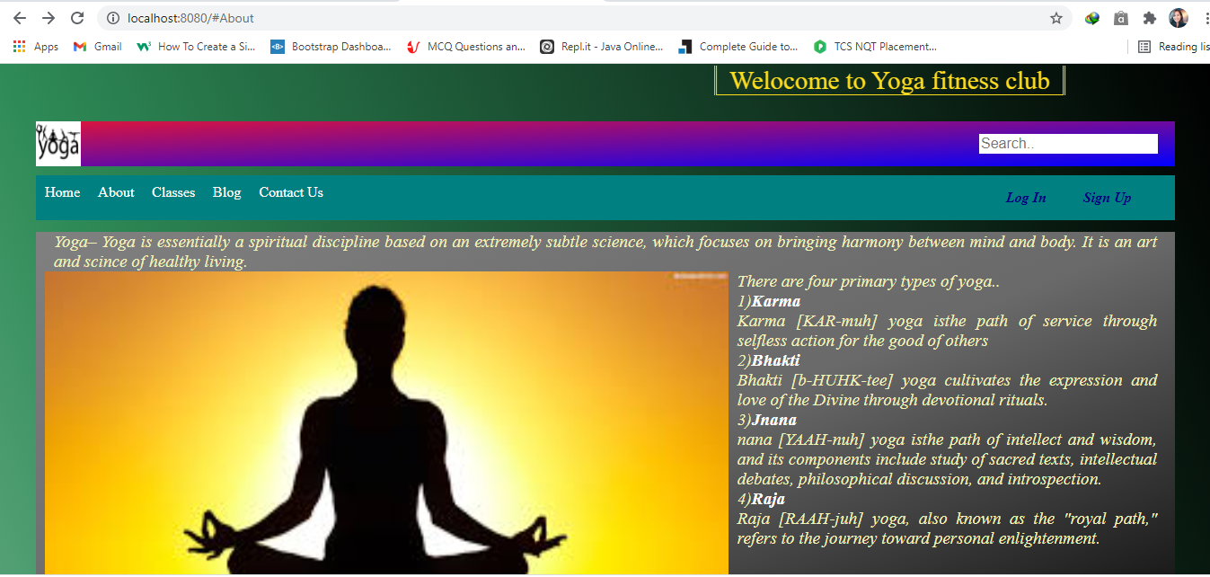

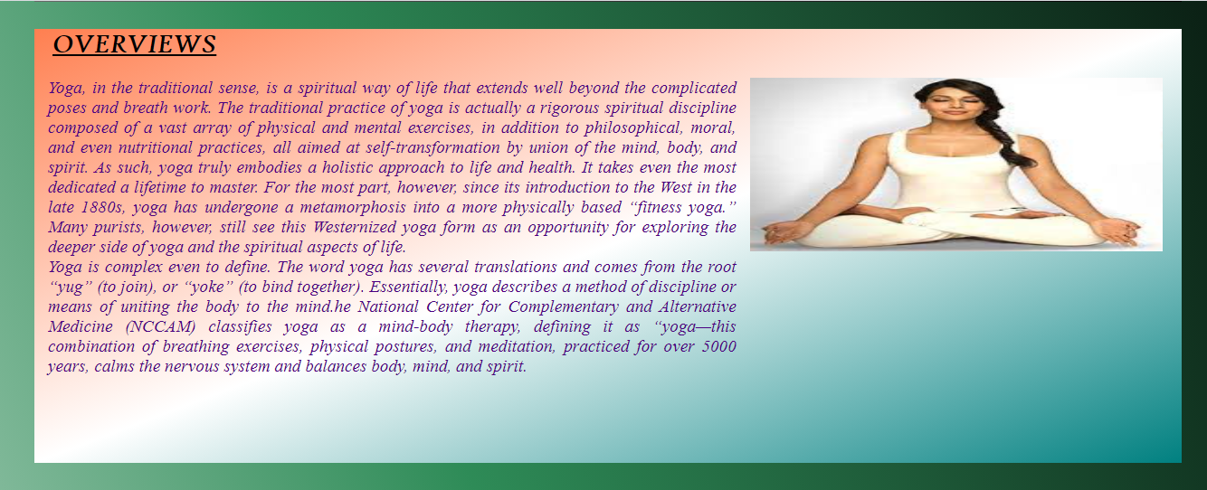

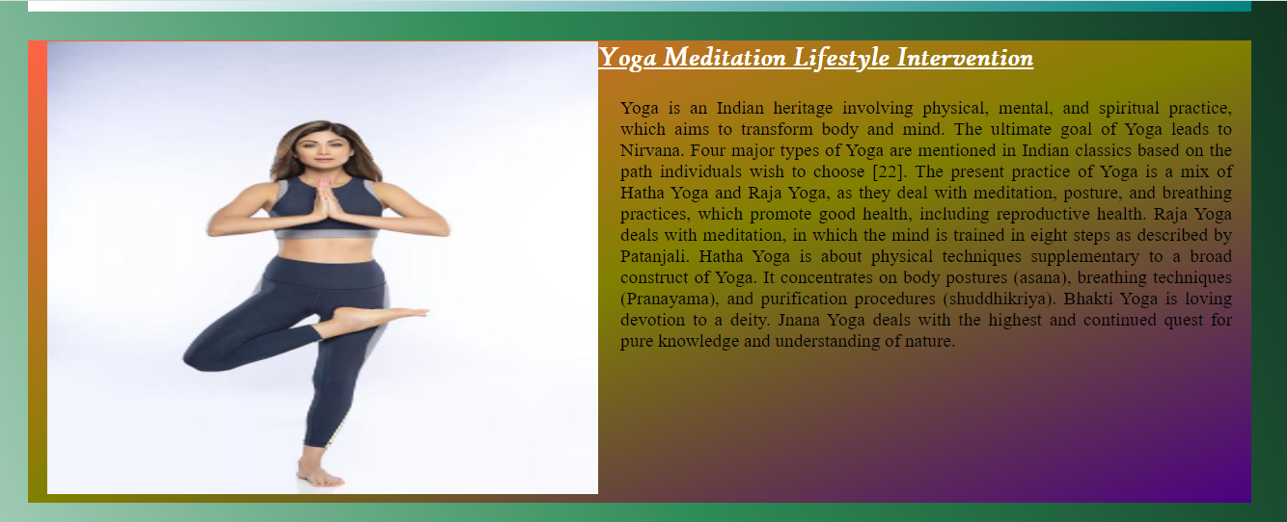

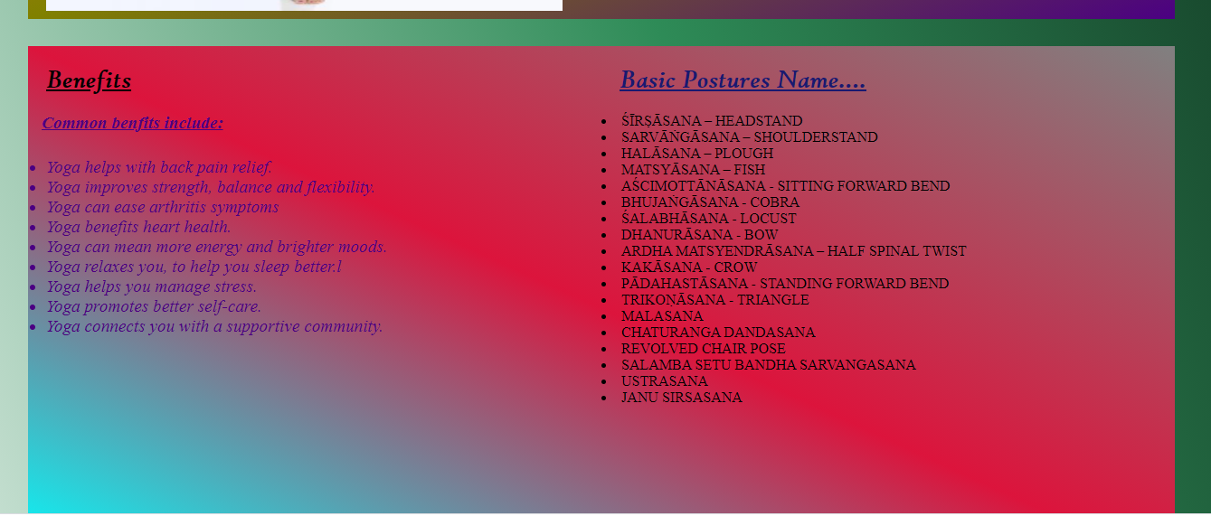

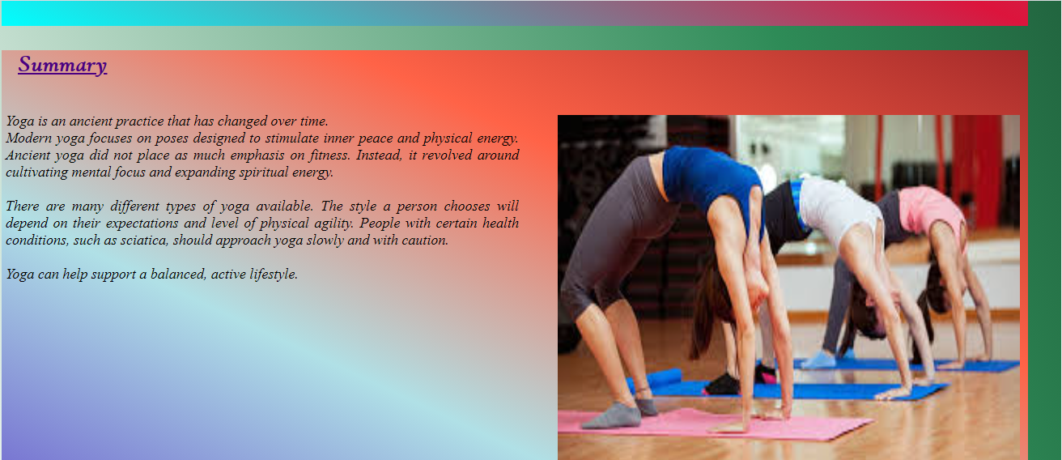



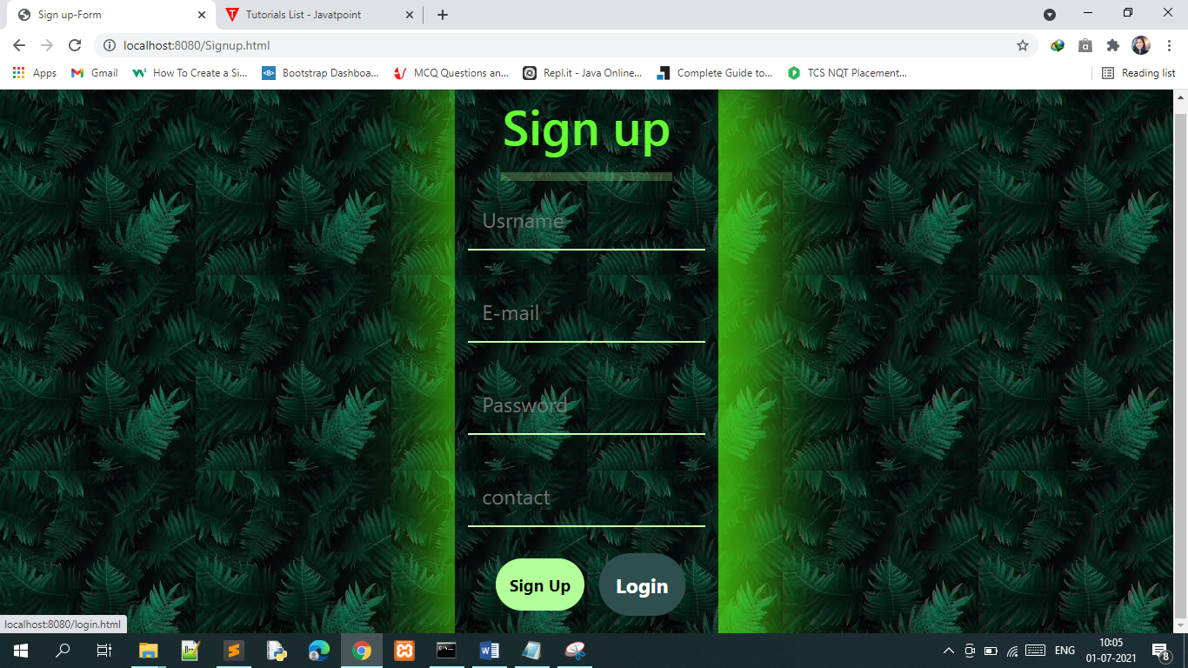

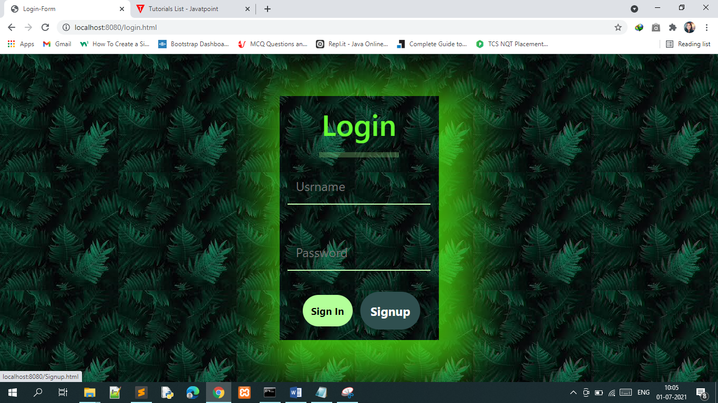



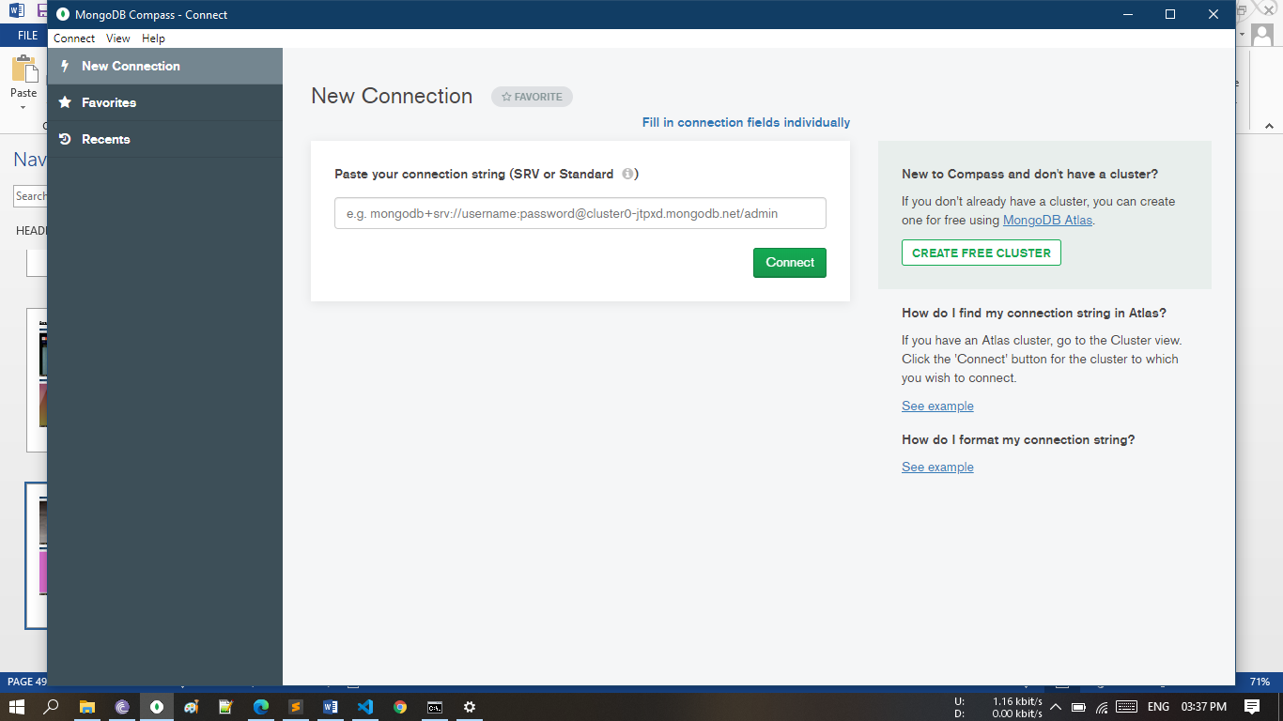

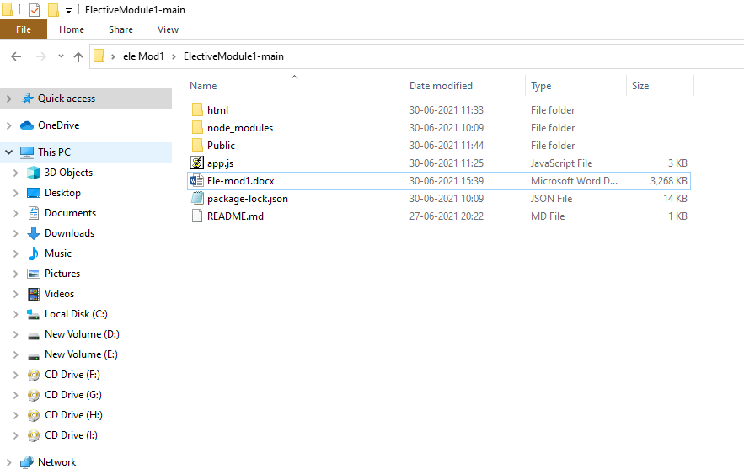

***Thank You***